**Lab 5**

**Q1**

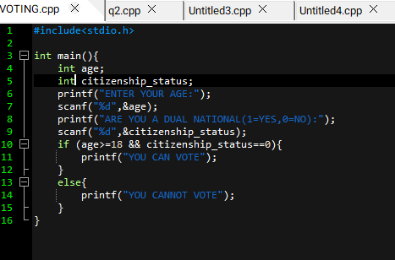

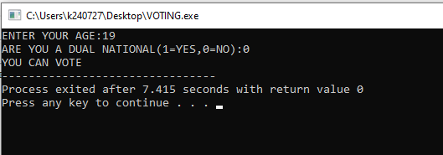

**Q2**

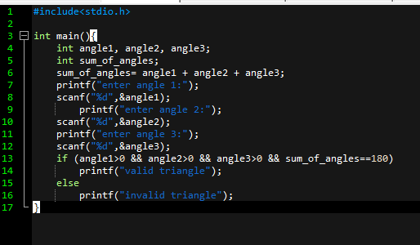

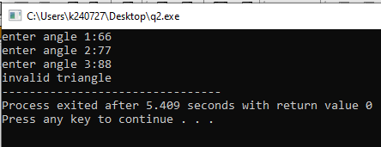

**Q3**

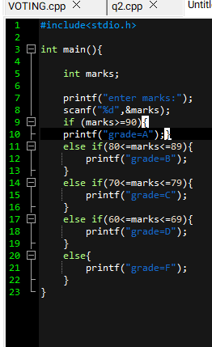

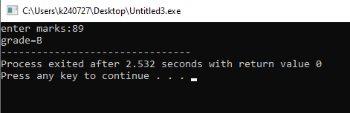

**Q4**

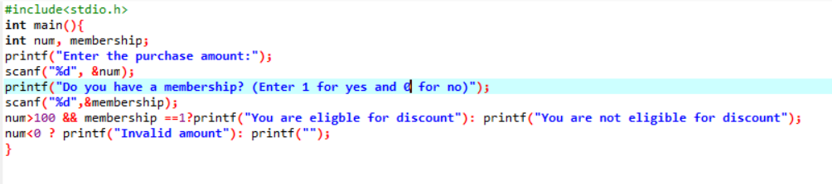

**Q5**

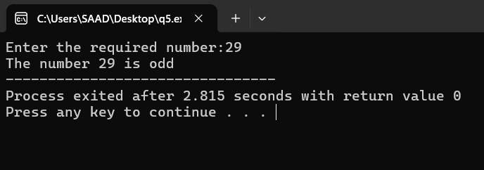

**Q6**



